- Three types of nutrients provide energy
  - protein
  - Carbohydrates
  - fats
- Carbohydrates: Starches and sugars found in foods which provide your body’s main source of energy.
- you should get 45 - 60 % of your calories from carbs
- Three types:
  - simple - Sugars such as fructose and lactose found in fruit and milk.
  - complex- starches, these are long chains of sugars linked together (grains, pasta, beans, root vegetables..)
    - The difference in simple and complex is in how quickly they are digested and their chemical makeup.
  - fiber- complex carb that the body cannot digest. It helps move waste throughout your digestive system.
    - help you feel full and can prevent cancer, heart disease and type 2 diabetes
    - Girls - 28grams/day boys - 38 grams/day
    - fruits, vegetables, whole grains, nuts, seeds
  - Your body uses Carbs by breaking them down to their simplest forms. Usually they are broken into a simple sugar called glucose which is the main source of fuel for the body. It can also be stored in tissue and used at a later time. (weight gain)
- Carbs: https://www.youtube.com/watch?v=-fSt7aWaVqE
- Protein: nutrients the body uses to build and maintain its cells and tissues.
- Your body uses 20 amino acids. 11 are produced by your body and called non-essential, the other 9 come from foods you eat and are called essential.
- meat, eggs, dairy products, Quinoa and soy are called complete proteins because they contain all 9 essential amino acids.
- You can get all 9 from eating a variety of nuts, beans and vegetables.
- Protein is the basic building material of your body cells, muscles, bones, skin and internal organs.
- Protein does a variety of other things as well, for example. Hemoglobin in your blood carries oxygen in your bloodstream to other parts of your body.
- Protein can also provide energy but takes much longer for your body to break down so is not an ideal source for energy.
- boys - 52 grams/day girls - 46 grams/day
- Protein: https://www.youtube.com/watch?annotation_id=annotation_927023009&feature=iv&src_vid=-fSt7aWaVqE&v=CzBGa8KnM3Q
- Fats:
- Two types of fat:
  - Saturated: More saturated with Hydrogen molecules, Less healthy fat
  - Unsaturated: Less saturated with Hydrogen molecules. Healthier Fat, Vegetable oils, nuts and seeds
    - Trans Fat: Formed by a process of hydrogenation, the oils solidify. They raise cholesterol and increase risk of heart disease
- Your body needs a certain amount of fat but eating too much can result in weight gain.
- Fats provide energy, help brain development, blood clotting and controlling inflammation.
- Calories not used are stored as fat deposits called adipose tissue.
- Eating saturated fats and trans fat increase the level of cholesterol which is a waxy fat like substance in your blood stream.
- Fat takes 100 times longer to metabolize than Carbohydrates
- Fats can be used for energy during endurance activities
- Teens should consume less than 25% - 30% of their diet in fats
- Vitamins are compounds found in foods that help regulate many body functions
- Vitamin C, Folic Acid, and B Vitamins are water soluble which means they are easily dissolved in the digestive process

- s and pass into the bloodstream. The body doesn’t store these vitamins. Unused vitamins are removed by the kidneys
- Vitamin A, D, E, K are fat soluble which means that they are stored in body fat for later use. If consumed in large amounts, they can be stored and eventually become harmful.
- Common Vitamins:
  - A- night vision, stimulates production of white blood cells, regulates cell growth, repairs bones and tissue, aids immunity, maintains healthy skin.
    - Carrots Sweet Potatoes, Tomatoes, Leafy vegetables, fish, liver, fortified milk and cereal, egg yolks
  - D - needed for building bones, aids immune function, regulates cell growth
    - fortified cereals and dairy products, fatty fish like salmon and tuna, sunlight
  - E - Protects Cells, aids blood flow, helps repair body tissue
    - Fish, milk, eggs, veg. oil, fruits, nuts, peas, beans, broccoli, spinach, fortified cereal
  - K - essential for blood clotting, aids bone formation
    - leafy vegetables, veg. oil, cheese, broccoli, tomatoes
  - B1 - Helps use carbs to produce energy, promotes health of nervous system
    - lean pork, liver, enriched and whole grain cereal
  - B2 - Helps use carbs, protein and fat, helps maintain healthy skin
    - lean beef, pork, organ meats, legumes, eggs, cheese, milk, nuts, enriched grain products
  - B3 - helps body process proteins and fats, maintains health of skin, nervous system and digestive system
    - liver, poultry, fish, beef, peanuts, beans, enriched grain
  - B6 - helps body use protein and fat, supports immune and nervous sys, helps blood carry oxygen, helps maintain blood sugar, breaks down iron and copper
    - organ meats, pork, beef, poultry, fish, eggs, peanuts, bananas, carrots
  - 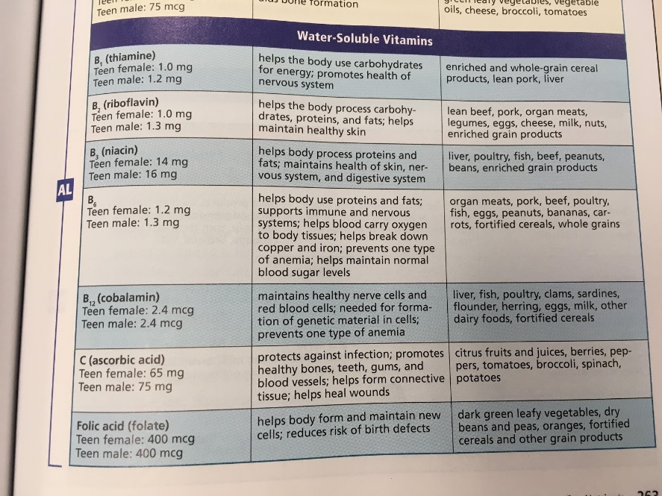
- Minerals are elements found in food that are used by the body.
- Your body cannot produce minerals so you must get them from food.
- One very important mineral is calcium which promotes bone health.
- Eating foods high in calcium can help prevent osteoporosis
- Osteoporosis - a condition in which the bones become fragile and break easily. It is most common in women over the age of 50
- You can prevent this now because bone mass builds most rapidly
- 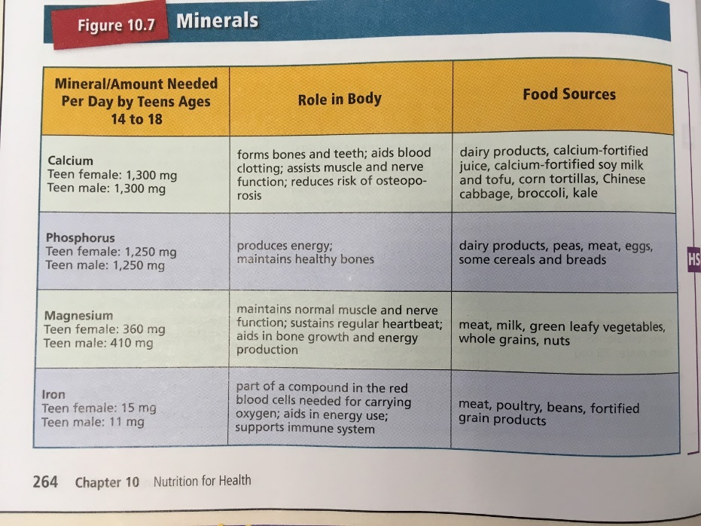
https://www.youtube.com/watch?v=ISZLTJH5lYg
Water
- 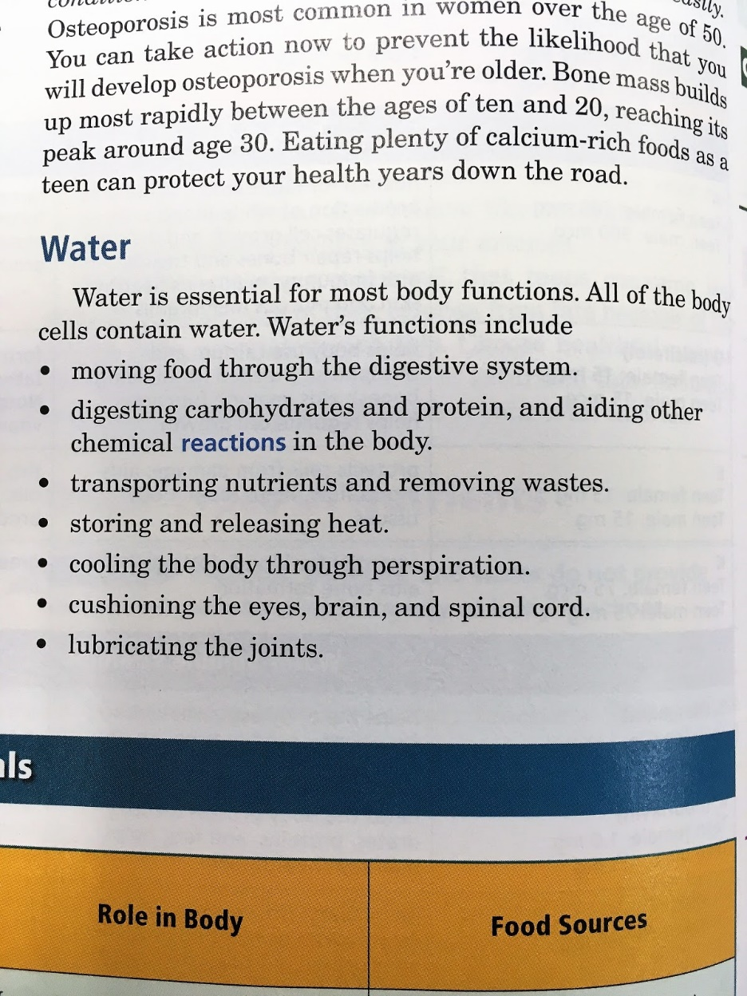
https://www.youtube.com/watch?v=9iMGFqMmUFs

